Student worksheet

7.1 The human body is divided into systems

Pages 116–117 and 203

Human body systems

1 Use the list below to identify which organs are involved in each system:

|  |  |  |  |  |  |
| --- | --- | --- | --- | --- | --- |
| *Brain* | *Nose* | *Muscles* | *Blood* | *Stomach* | *Mouth* |
| *Lungs* | *Small intestine* | *Heart* | *Diaphragm* | *Oesophagus* | *Large intestine* |
| *Liver* | *Veins* | *Spinal cord* | *Windpipe* | *Bones* | *Nerves* |
|  | |  | |  | |
| SKELETAL SYSTEM | | NERVOUS SYSTEM | | CIRCULATORY SYSTEM | |
|  | |  | |  | |
|  | |  | |  | |
| RESPIRATORY SYSTEM | | DIGESTIVE SYSTEM | | MUSCLE SYSTEM | |

2 Draw a flowchart that depicts the pathway from cells to body systems.

3 When and where did the first scientists to study anatomy live?

4 Why did they perform dissections?

5 What is involved in the mummification process?

6 How did da Vinci start his studies on anatomy?

7 What was da Vinci able to model from his investigations of the heart?

8 What would da Vinci have discovered if he had finished his work?

9 What is a corpse?

10 In the 1700s, how were bodies obtained for medical students to perform dissections?

11 List three advances that occurred due to the improvement in medical care of the 1700s.

Extend your understanding

12 How do you know that each of your body systems is working? Using your general knowledge, state three things that occur on a daily basis that proves that each of these six body systems is working.

|  |  |
| --- | --- |
|  |  |
| SKELETAL SYSTEM | NERVOUS SYSTEM |
|  |  |
| CIRCULATORY SYSTEM | RESPIRATORY SYSTEM |
|  |  |
| DIGESTIVE SYSTEM | MUSCLE SYSTEM |

Student worksheet

7.2 The digestive system is made up of organs

Pages 118–119 and 204-205

The digestive system

1 What is digestion?

2 What are nutrients?

3 How do nutrients travel to where they are needed within the body?

4 What is chemical digestion? Give an example.

5 What is mechanical digestion? Give an example.

6 Label the following diagram of the mouth.

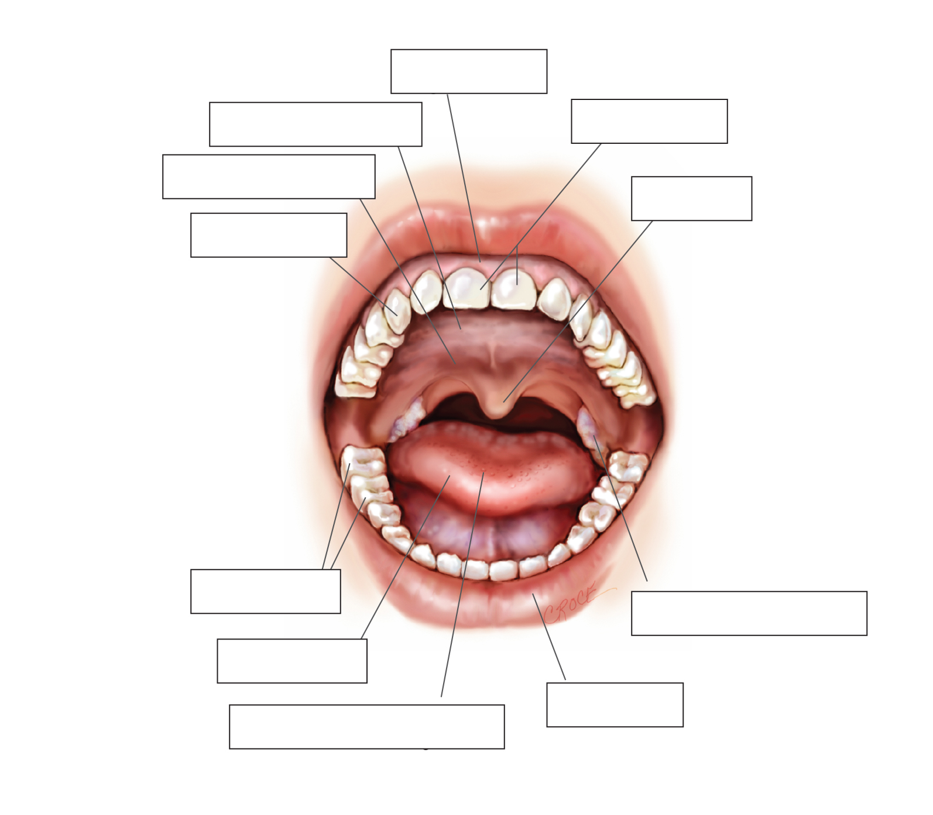

7 Label the following diagram of the digestive system.

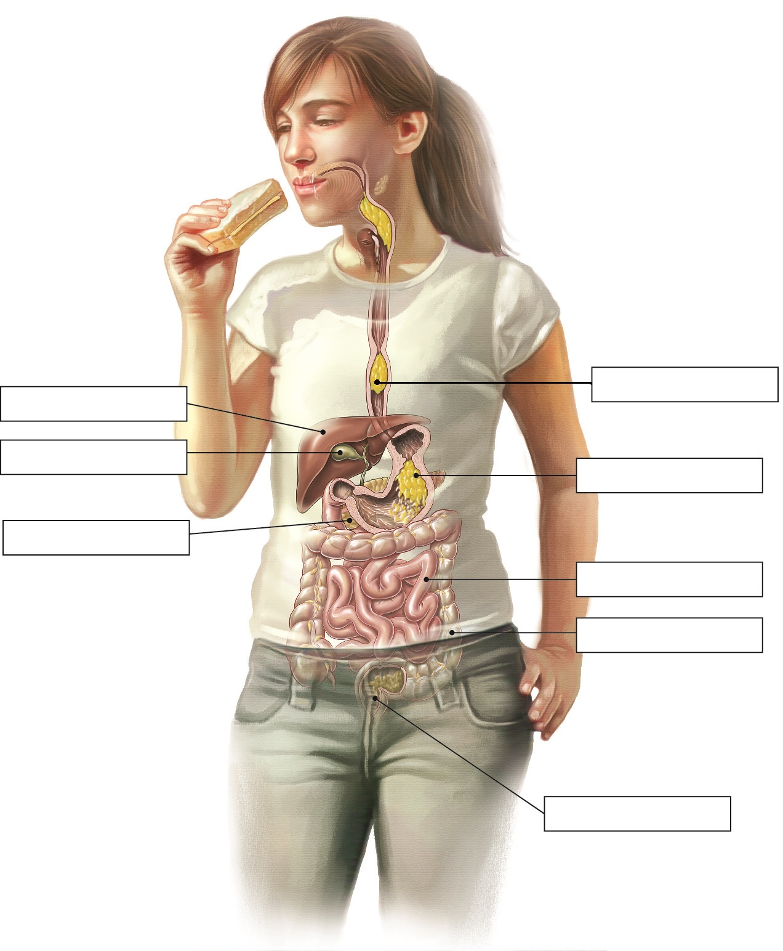

8 Match the organ with its function.

|  |  |  |
| --- | --- | --- |
| ORGAN |  | FUNCTION |
| 1 Stomach |  | A Makes a type of juice that contains a mixture of digestive enzymes, and also neutralises stomach acid |
| 2 Liver and gall bladder |  | B Tubular muscle that forces food down to your stomach in a process called peristalsis |
| 3 Mouth |  | C Absorbs nutrients that feed all cells of the body; villi help to increase the surface area of this organ for better absorption |
| 4 Rectum and anus |  | D Stores faeces until it starts to become full, then pushes the faeces out of a ring of muscle |
| 5 Large intestine |  | E Stores food for about three hours while it uses gastric juice to help digest it |
| 6 Oesophagus |  | F Where water and some vitamin absorption occurs; it is the body’s last chance to absorb nutrients |
| 7 Pancreas |  | G Location of salivary glands that make saliva, which contains enzymes to start chemical digestion |
| 8 Small intestine |  | H Makes a mixture of chemicals called bile, which is used to digest fat and neutralise (deactivate) stomach acid |

Extend your understanding

9 The human body contains enzymes to aid in the chemical breakdown of foods. What is an enzyme?

10 Research the following five enzymes: *amylase, pepsin, protease, lactase, lipase*From what you have learned, complete the following sentences by matching each enzyme with its function and correct organ in the digestive system:

a Amylase is able to break down _________________________ into _______________________ and is found in the _____________________________________________________________

b Pepsin is able to break down _________________________ into _______________________ and is found in the ____________________________________________________________

c Protease is able to break down _________________________ into ______________________ and is found in the _____________________________________________________________

d Lactase is able to break down _________________________ into ______________________ and is found in the ____________________________________________________________

e Lipase is able to break down _________________________ into _______________________ and is found in the ____________________________________________________________

11 What is the function of bile?

12 Why is bile not considered to be an enzyme?

Student worksheet

7.3 The digestive system varies between animals

Pages 120–121

The digestive systems of various animals

1 What is the function of the each of the different types of teeth?

2 How would a palaeontologist be able to tell if an animal was a carnivore, herbivore or omnivore?

3 Are humans categorised as carnivores, herbivores or omnivores? How can you tell?

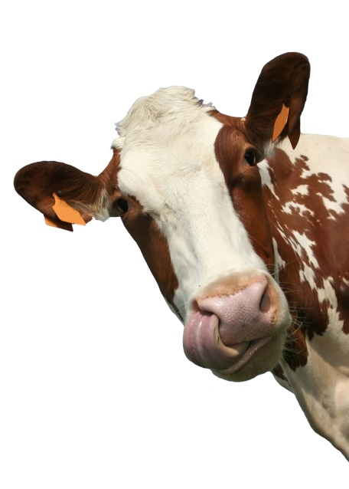

4 What is the function of the caecum?

5 Why would animals have a caecum?

6 What is the problem with the position of the caecum on the digestive tract? How do some animals overcome this problem?

7 What is the major difference between a cow’s and a human’s digestive system?

8 What is a ruminant?

9 What other animals are ruminants?

10 Using the information on page 121 of your student book and your knowledge of the function of digestive organs, match the organ involved in a cow’s digestive system with its function.

|  |  |  |
| --- | --- | --- |
| Organ |  | Function |
| 1 Omasum |  | A Absorption of chemicals into the blood stream |
| 2 Rumen |  | B Chewed grass moves through this pathway to the next organ |
| 3 Small intestine |  | C Second compartment of the stomach: grass is softened and clumps together to form cud |
| 4 Oesophagus |  | D Contains the milk in cows that have given birth to a calf |
| 5 Udder |  | E First compartment of the stomach: grass is softened by fluids |
| 6 Abomasum |  | F Absorbs, re-circulates and conserves water and minerals |
| 7 Large intestine |  | G Fourth compartment of the stomach: breaks food down into biomolecules (protein, vitamins, simple carbohydrates, fats and amino acids) |
| 8 Reticulum |  | H Third compartment of the stomach: cud is pressed and reduced in size |

Extend your understanding

The udder contains the milk in cows that have given birth to a calf. It takes up to 70 hours for a cow to turn grass into milk. For every litre of milk a cow makes, more than 400 litres of blood must travel around her udder to deliver the nutrients from the grass. Australian dairy cows produce about 15 litres of milk a day.

11 If a cow produces 15 litres of milk per day, how much blood must travel around their udder each day?

12 How much milk is a female cow capable of producing in one year?

13 How much milk are 100 female cows capable of producing in one year?

14 A farmer has 100 cows on a farm. If she wants to produce 684 375 litres of milk each year, how many more cows will she need to purchase?

Student worksheet

7.4 Things sometimes go wrong in the digestive system

Pages 122–123

Problems in the digestive system

Stomach ulcers

1 In which digestive organ do stomach ulcers form?

2 What is the cause of stomach ulcers?

3 What effect does a stomach ulcer have on your body?

4 What is the treatment for stomach ulcers?

5 Who first developed this treatment and what were they awarded for their efforts?

Gallstones

6 In which digestive organ do gallstones form?

7 What is the cause of gallstones?

8 What effect does a gallstone have on your body?

9 What is the treatment for gallstones?

Gluten intolerance

10 What are the symptoms of gluten intolerance?

11 What is the cause of gluten intolerance?

12 What effect does gluten intolerance have on your body?

13 What is the treatment for gluten intolerance?

Constipation

14 In which digestive organ does constipation occur?

15 What is the cause of constipation?

16 What effect does constipation have on your body?

17 What is the treatment for constipation? What may happen if it is left untreated?

Extend your understanding

18 Choose one of the three digestional conditions below and answer the following questions.

*Heart burn/reflux Lactose intolerance Crohn’s disease*

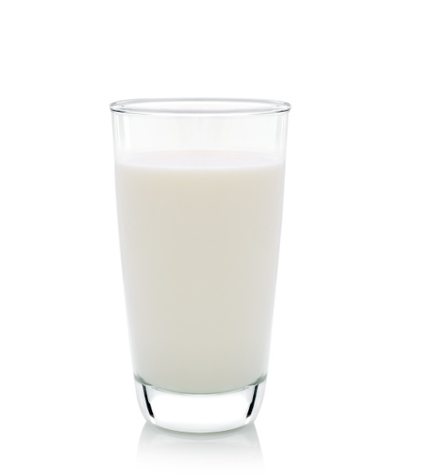a What is the cause and the digestive organ responsible for this condition?

b What effects can this condition have on your body?

c What is the treatment?

d Is there any way to manage the condition to avoid it happening again or to limit ongoing effects?

Student worksheet

7.5 The respiratory system exchanges gases

Pages 124–125 and 206

The respiratory system

1 What is the function of the respiratory system?

2 What is cellular respiration and why is it important?

3 Describe the path that oxygen takes through the mouth and into the blood.

4 What is the structure and function of alveoli?

5 Why do capillaries cover each alveolus?

6 Why do some capillaries appear to be red and others appear to be blue?

7 What is the structure and function of the diaphragm?

8 Explain the movement of the diaphragm when inhaling and exhaling.

9 What is the function of the ring of cartilage that surrounds the trachea (windpipe)?

10 Label the following diagram of the respiratory system.

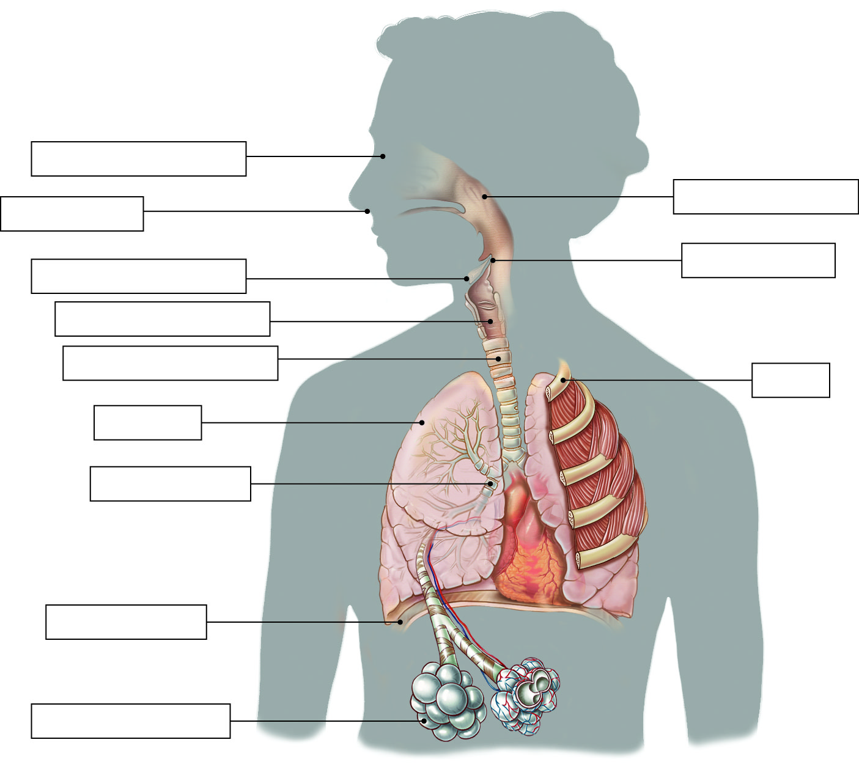

Extend your understanding

Plants have an alternative system of exchanging gases.

11 Why is the plant exchange of gases called respiration rather than breathing?

12 What is the name of the process that plants use to convert carbon dioxide into sugars? Write an equation for this process.

13 Which gas do plants use in this reaction, and which gas is released as waste?

14 What is the name of the organ within a leaf where this process occurs?

15 What is the name of the pigment that is necessary for this process and what colour is it?

16 Why are plants green?

Student worksheet

7.6 Things sometimes go wrong in the respiratory system

Pages 126–127

Problems in the respiratory system

Coughing and sneezing

1 In which respiratory organ does coughing and sneezing occur?

2 What is the cause of coughing?

3 What is the cause of sneezing?

4 How fast are some sneezes?

Asthma

5 How many Australians are affected by asthma?

6 In which respiratory organ does asthma occur?

7 What is the cause of asthma?

8 What effect does asthma have on your body?

9 What is the treatment for asthma?

Emphysema

10 In which respiratory organ does emphysema occur?

11 What is the main cause of emphysema?

12 What effect does emphysema have on your body?

13 What is a treatment for emphysema?

Pneumonia

14 In which respiratory organ does pneumonia occur?

15 What is the cause of pneumonia?

16 What effect does pneumonia have on your body?

17 What is the treatment for pneumonia?

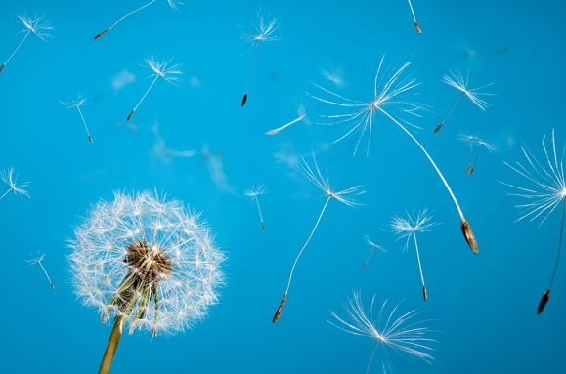Extend your understanding

18 Choose one of the three respiratory conditions below and answer the following questions.

*Hayfever*

*Cystic fibrosis*

*Chronic obstructive pulmonary disease (COPD)*

a In which respiratory organ does the condition occur?

b What is the cause of this condition?

c What effects can this condition have on your body?

d What is the treatment?

e Is there any way to manage the condition to avoid it happening again or to limit ongoing effects?

Student worksheet

7.7 The circulatory system carries substances around the body

Pages 128–129 and 207

The circulatory system

1 What is the function of the circulatory system?

2 How many chambers are there in a human heart?

3 What are the top chambers called?

4 What are the bottom chambers called?

5 Which side pumps blood to the lungs?

6 Which side pumps blood around the body?

7 Why are the left side and the muscles surrounding it bigger than the right side?

8 Label the following diagram of the heart.

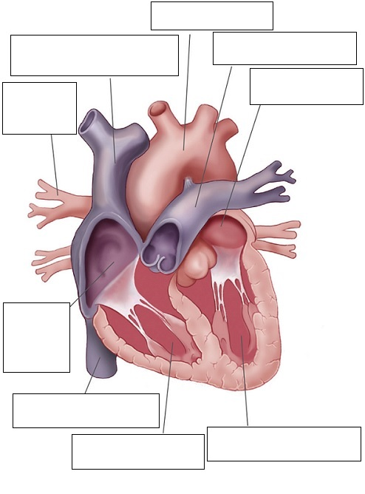

9 Match each component of blood to its function:

|  |  |  |
| --- | --- | --- |
| BLOOD COMPONENT |  | FUNCTION |
| 1 Plasma |  | A Cell fragments that travel in the blood to cuts to block the cuts and stop bleeding |
| 2 White blood cells |  | B Carry oxygen to the body’s tissues and carbon dioxide away from them |
| 3 Haemoglobin |  | C Nutrients and wastes are dissolved in it for transport to and from cells |
| 4 Platelets |  | D Germ fighters |
| 5 Red blood cells |  | E Carries oxygen in red blood cells |

10 Which type of blood vessel carries blood toward the heart?

11 Which type of blood vessel carries blood away from the heart?

12 Describe the structure and function of capillaries.

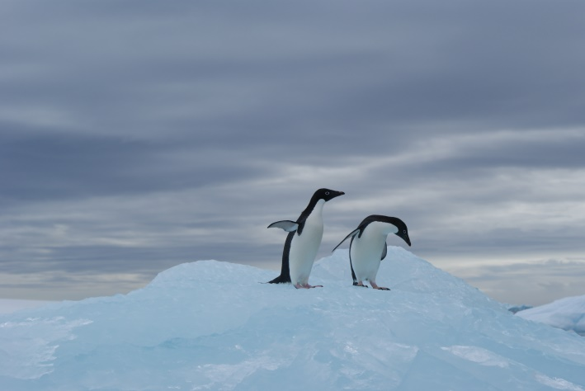Extend your understanding

Animals have various adaptations that allow them to survive the effects of extreme weather conditions. Penguins stand on cold ice, sometimes for months on end, without losing feeling in their feet or getting frostbite. This is because penguins have two main adaptations that involve their circulatory system.

13 Research the following adaptations and explain how each occurs in terms of the circulatory system.

a Penguins control the blood flow to their feet.

b Penguins have countercurrent blood flow systems.

Student worksheet

7.8 Things sometimes go wrong in the circulatory system

Pages 130–131 and 208

Problems in the circulatory system

Valve disease

1 In which cardiovascular organ does valve disease occur?

2 What is the cause of valve disease?

3 What are the effects of valve disease?

4 What is a symptom of valve disease?

Atherosclerosis

5 In which cardiovascular organ does atherosclerosis occur?

6 What is the cause of atherosclerosis?

7 What effect does atherosclerosis have on your body?

Coronary heart disease

8 In which cardiovascular organ does coronary heart disease occur?

9 What is the cause of coronary heart disease?

10 What effect does coronary heart disease have on your body?

11 What is the best way to avoid coronary heart disease?

Pericarditis

12 In which cardiovascular organ does pericarditis occur?

13 What is the cause of pericarditis?

14 What effect does pericarditis have on your body?

15 What is the treatment for pericarditis?

Extend your understanding

16 Choose one of the four cardiovascular conditions below and answer the following questions:

*Cardiomyopathy Angina High blood pressure High cholesterol*

a In which cardiovascular organ does the condition occur?

b What is the cause of this condition?

c What effects can this condition have on your body?

d What is the treatment?

e Is there any way to manage the condition to avoid it happening again or limit ongoing effects?

Student worksheet

7.9 The excretory system removes waste

Pages 132–133 and 208

The excretory system

1 What is the function of the excretion system?

2 Why is water important in controlling wastes?

3 Explain how the digestion of proteins produces ammonia and urea

4 Label the organs involved in the excretory system.

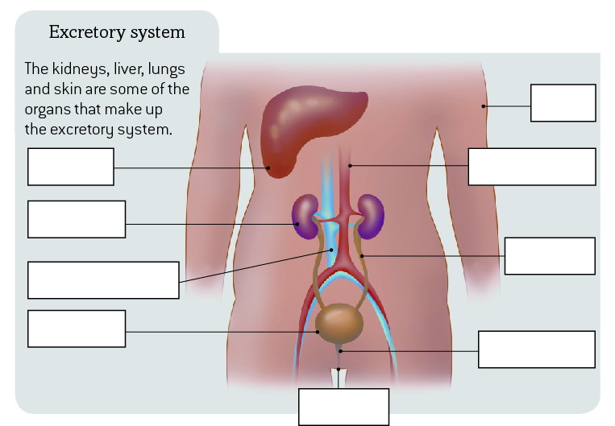

5 Label the main parts of a kidney and nephron.

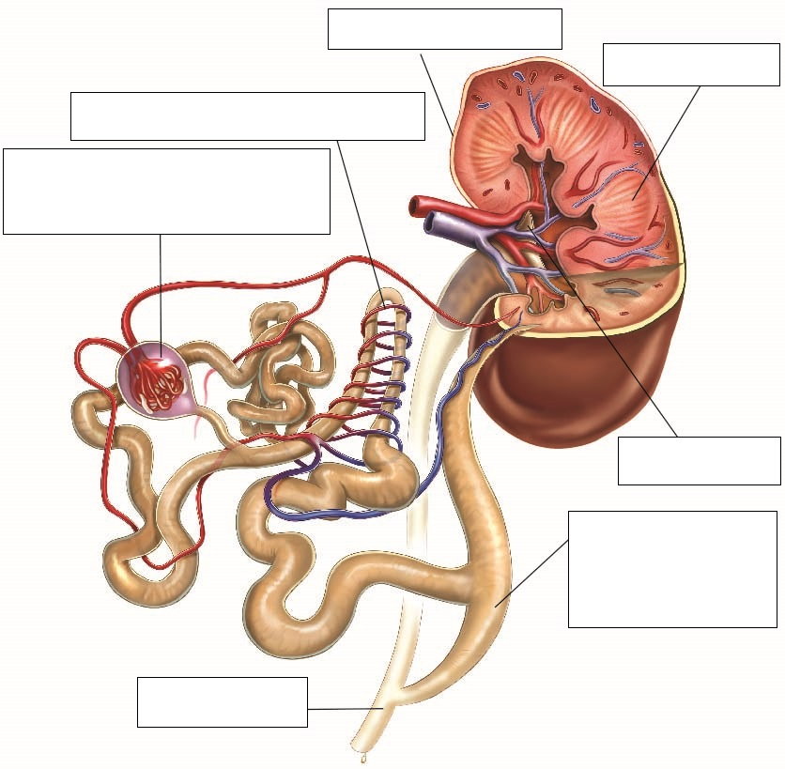

6 What is the function of the liver in the excretion system?

Extend your understanding

If your kidneys do not work properly, removing wastes can be difficult. People with kidney problems may need to undergo frequent treatments, called dialysis, to perform the function that the kidneys cannot.

7 What is the function of the kidney in the excretion system?

8 If your kidneys do not work and dialysis must be performed, what is the function of dialysis treatment?

9 Research how dialysis works. Explain this process in very simple terms.

10 Is there a cure for kidney failure? Explain what the options are for people whose kidneys shut down permanently.

Student worksheet

7.10 Plants have tissues and organs

Pages 134–135 and 209–210

Plant systems

1 What is the function of roots in a plant?

2 What is the function of the stem in a plant?

3 What is the function of leaves in a plant?

4 What is the function of the vascular bundle in the stem?

5 What are the two main components of the vascular bundle and what does each do?

6 Label the vascular bundle of a plant stem by identifying the two main components from question 5.

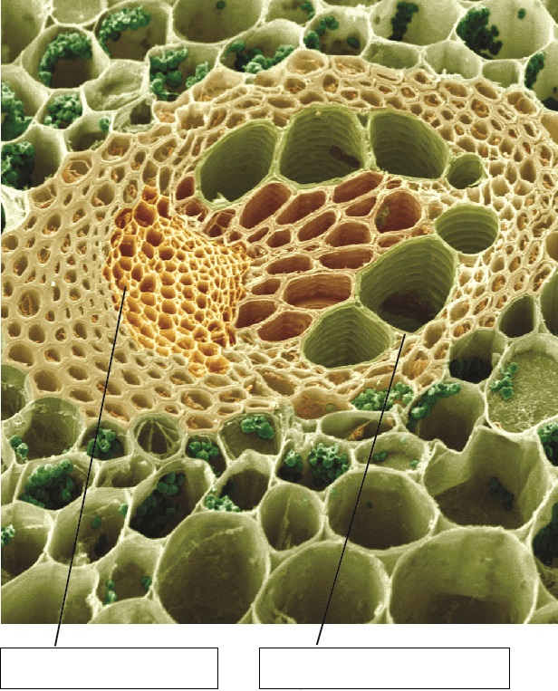

7 Leaves contain specialised structures called stomata. Label the diagram of a stoma below.

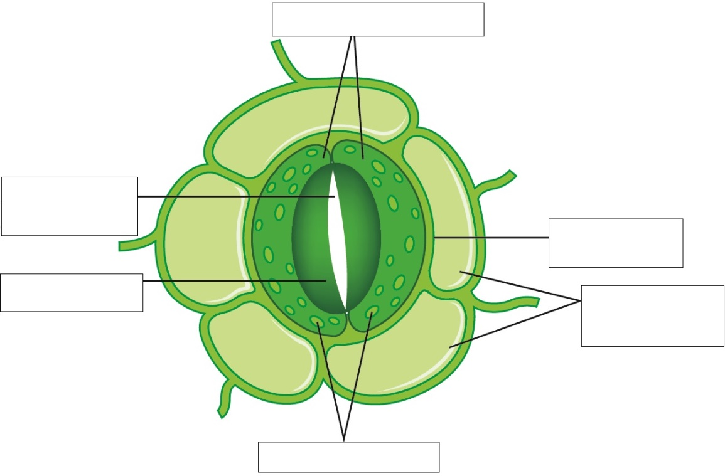

8 What are the main functions of stomata?

Extend your understanding

Guard cells of stomata help to regulate the process of transpiration in plants by opening and closing the stoma (opening). It is the process by which water is carried through the plant to the leaves where it evaporates into the atmosphere through the stomatal pore. When the guard cells are turgid (swollen), the stoma is open; when guard cells are flaccid, the stoma will close.

9 Explain what would happen to the water in a plant in the following situations, and whether the stomatal pore would be open or closed.

a A hot summer day

b A cool winter day

c A succulent plant in the desert

d A deciduous tree in winter